## Chapter 5.1 Grammatical Analysis and Pre - Processing

In this Chapter, we will discuss the Grammatical Analysis of SQL, and give the basic Grammatical Necessitates of this language. Of course, we will discuss Query that includes one virtual view and some other Pre - Processing steps.

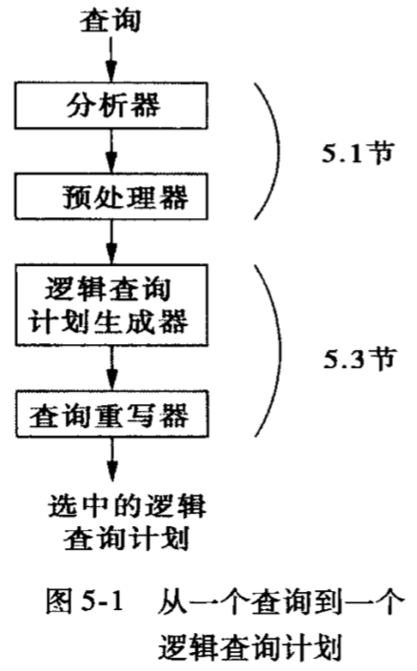

### Chapter 5.1.1 Grammatical Analysis and Grammatical Analysis Tree

The task of Grammatical Analysis is receive the text wrote by SQL and converted to the Grammatical Analysis Tree, the nodes of this tree belongs to two of below:

1. Atom: They belongs to Lexical Type.

* Example: Key Word(Select), Relation Name, Attribute Name, Constant, Brackets, Operators, and other Module Elements.

1. Grammar Type: Query Sub - Composition that makes sense in one Query. Here we use Angle Brackets to represent the Grammar Type by enclosing those descriptive names.

* Example: <Query> is used to present Query with form of select - from - where. <Condition> is used to present any expressions that belongs to conditions, for example, those expressions following after WHERE in SQL.

If the current point is the type of Atom, then the Atom has no Sub - Atom. But if the Atom is the type of Grammar Type, then its Sub - Atom uses the Grammar Rule to describe it.

### Chapter 5.1.2 One Simple Collection of Grammar in SQL

### Chapter 5.1.3 Pre - Processing

### Chapter 5.1.4 Query that Pre - Processing involves View